# TEAM LEAD VERSION (DevOps-Week-9)

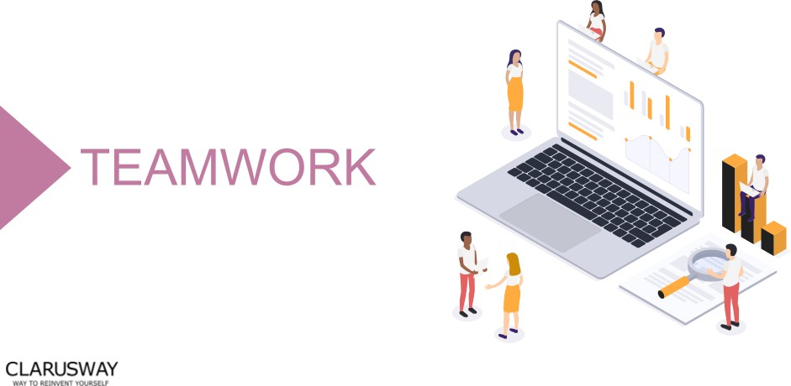

**Meeting Agenda**

▶ Icebreaking

▶ Questions

▶ Interview/Certification Questions

▶ Coding Challenge

▶ Article of the week

▶ Video of the week

▶ Retro meeting

▶ Case study / project

**Teamwork Schedule**

**Ice-breaking 5m**

Personal Questions (Stay at home & Corona, Study Environment, Kids etc.) Any challenges (Classes, Coding, AWS, studying, etc.)

Ask how they’re studying, give personal advice. Remind that practice makes perfect.

**Team work 10m**

Ask what exactly each student does for the team, if they know each other, if they care for each other, if they follow and talk with each other etc.

**Ask Questions 15m**

1. **Can we run Junits as a part of Jenkins job?**
   1. True
   2. False

**Answer:** *A*

1. **Which variable contains the directory which contains logs, jobs, users and other configurations of jenkins?**
2. HOME
3. HOME_JENKINS
4. JENKINS_HOME
5. JENKINS

**Answer:** *C*

1. **Declarative pipeline starts with which tag?**
   1. node
   2. pipeline
   3. stage
   4. step

**Answer:** *B*

1. **Which scripting language is used in Jenkins?**
   1. bash
   2. python
   3. groovy
   4. perl

**Answer:** *C*

1. **Which function is used in pipeline to get the secrets/credentials?**
   1. withCredentials
   2. withData
   3. withSecret
   4. withPassword

**Answer:** *A*

**Interview/Certification Questions 20m**

* + 1. **Which of the following helps you set up a logically isolated section of your AWS cloud?**
       1. AWS Subnets
       2. AWS VPC
       3. AWS Regions
       4. AWS Availability Zones

**Answer:** *B*

*Amazon Virtual Private Cloud (Amazon VPC) enables you to launch AWS resources into a virtual network that* you've defined. This virtual network closely resembles a traditional network that you'd operate in your own data center, with the benefits of using the scalable infrastructure of AWS.

*For more information on AWS VPC, Refer:* [Link](https://docs.aws.amazon.com/AmazonVPC/latest/UserGuide/VPC_Introduction.html)

* + 1. **Which statements regarding VPC Peering is accurate? Select TWO.**
       1. Two VPCs in different AWS Regions and under separate AWS Accounts can share traffic between each other.
       2. In order for VPC Peering to work each VPC should have a public subnet.
       3. In VPC Peering, it is possible for traffic from one VPC to traverse through a transit VPC in order to reach a third VPC.
       4. Traffic between VPC peers in different AWS Regions is not encrypted by default.
       5. VPC Peering can be used to replicate data to geographically distinct locations for fault-tolerance, disaster recovery and redundancy

**Answer:** *A and E*

*VPC Peering can be established between VPCs in different AWS Regions and in separate AWS Accounts. The logical* networks still use the same common AWS backbone network infrastructure to communicate. By utilizing this infrastructure, VPC Peering makes it possible to securely store mission-critical data to geographically distinct locations for fault-tolerance, disaster recovery and redundancy. [Link](https://docs.aws.amazon.com/vpc/latest/peering/what-is-vpc-peering.html)

*Option B. is INCORRECT because VPC Peering can still work without the use of public IP addresses. Private IP* address subnets can be routed between peers as long as their respective CIDR block ranges do not overlap.

*Option C. is INCORRECT because it is not permissible on the AWS cloud to route traffic of one VPC peer through a* transitive peer to get to a third VPC. [Link](https://docs.aws.amazon.com/vpc/latest/peering/invalid-peering-configurations.html)

*Option D. is INCORRECT because traffic between VPC peers in different AWS Regions is indeed encrypted by* default

## Which of the following security features is associated with a Subnet in a VPC to protect against Incoming traffic requests?

1. AWS Inspector
2. Subnet Groups
3. Security Groups
4. Network ACL

**Answer:** *D*

*A network access control list (ACL) is an optional layer of security for your VPC that acts as a firewall for* controlling traffic in and out of one or more subnets. You might set up network ACLs with rules similar to your security groups in order to add an additional layer of security to your VPC.

*For more information on Network ACL’s, Refer:* [Link](https://docs.aws.amazon.com/AmazonVPC/latest/UserGuide/VPC_ACLs.html)

## Which of the following are the main functions of AWS Route 53? (SELECT THREE)

* + - 1. Register domain names
      2. Route internet traffic to the resources for your domain
      3. Load-balance traffic among individual AWS resource instances
      4. Check the health of your resources
      5. Auto Scale your resources

**Answer:** *A,B and D*

*Option C is incorrect because Route 53 is not used for load-balancing traffic among individual AWS resource* instances (like a load balancer) rather we integrate it with resources for added functionality [Link](https://docs.aws.amazon.com/Route53/latest/DeveloperGuide/integration-with-other-services.html)

*Option E is incorrect. In AWS, Autoscaling is used to scale underlying resources up or down based on* predetermined or dynamic factors.

## There is a website hosted in AWS that might get a lot of traffic over the next couple of weeks. If the application experiences a natural disaster at this time, what should be used to reduce potential

**disruption to users?**

1. Use an ELB to divert traffic to an Infrastructure hosted in another region.
2. Use an ELB to divert traffic to an Infrastructure hosted in another AZ.
3. Use CloudFormation to create backup resources in another AZ.
4. Use Route53 to route requests to another instance in a different region

**Answer:** *D*

*In a disaster recovery scenario, the best choice out of all given options is to divert the traffic to a static website.* Option A is wrong because ELB can only balance traffic in one region, not across multiple regions.

*Options B and C are incorrect because using backups across AZs is not enough for disaster recovery purposes.*

For more information on disaster recovery in AWS, please visit the following Links: [Link-1](https://aws.amazon.com/premiumsupport/knowledge-center/fail-over-s3-r53/), [Link-2](https://aws.amazon.com/disaster-recovery/)

*The wording "to reduce the potential disruption in case of issues" is pointing to a disaster recovery situation. There* is more than one way to manage this situation. However, we need to choose the best option from the list given

*here. Out of this, the most suitable one is Option D.*

**Article of the Week 10m**

[Top 5 Aws Jobs That You Can Apply](https://clarusway.com/top-5-aws-jobs-that-you-can-apply/)

**Video of the Week 10m**

[Continuous Deployment vs. Continuous Delivery](https://www.youtube.com/watch?v=LNLKZ4Rvk8w)

**Retro Meeting on a personal and team level 10m**

Ask the questions below: What went well?

What could be improved?

What will we commit to do better in the next week?

**Coding Challenge 5m**

[Coding Challenge - 09 : Convert Milliseconds into Hours, Minutes, and Seconds with Bash Scripting](https://github.com/clarusway/clarusway_devops_10_22/tree/main/coding-challanges/cc-009-convert-millisecs-to-hours-mins-secs-with-bash)

**Case study/Project 10m**

**Case study should be explained to the students during the weekly meeting and has to be completed in one week by the students. Students should work in small teams to complete the case study.**

[Project-208: Jenkins Pipeline for Web Page Application (Postgresql-Nodejs-React) deployed on EC2's with Ansible and Docker](https://github.com/clarusway/clarusway_devops_10_22/tree/main/projects/208-jenkins-pipeline-for-webpage-application(postgresql-nodejs-react))

**Closing 5m**

-Next week’s plan

-QA Session